**1) Identify 4 the most relevant configurations for testing any online store based on collected statistics or experience on the most popular browsers, OS, devices, etc.**

* Windows - Google Chrome
* MacOS - Safari
* Windows - Edge
* Windows - Firefox

**2) Write a checklist that should contain at least 5 checks for each selected part (for example, header, content, footer, log in, registration). There should be three parts.**

**Checklist -** Rozetka.com.ua

**Header**

* Check that the burger menu opens when clicking on the burger menu button
* Check that it is possible to enter some text to the search field
* Check that the “Search” button is clickable
* Check if after clicking on the “user” icon user-identification window appear when the user isn’t logged in
* Check if “Bin” opens after clicking on the “bin” icon

**Content**

* Check the carousel images
* Check the main-categories list
* Check if the buttons in the main-categories list are clickable
* Check if the buttons from the main catalog redirect to the necessary category
* Check if the sale deals appear in the content menu

**Footer**

* Check if the button “Download from the Google Play” redirects to the Play Store
* Check if the button “Download from the App Store” redirects to the AppStore
* Check if the “Social Media” buttons redirect to the corresponding social media
* Check if the links from the block “Information about work” are clickable
* Check if the links from the block “Services” are clickable
* Check if the links from the block “Help” are clickable
* Check if the links from the block “To partners” are clickable

**3) Check the checklist in the following browsers, paying particular attention to the GUI in each browser (Safari, Google Chrome, Opera)**

| Checklist | Safari (15.5 (17613.2.7.1.8)) | Google Chrome (102.0.5005.61) | Opera (87.0.4390.45) |
| --- | --- | --- | --- |
| 1.Font size validation | Passed | Passed | Passed |
| 2.Page layout in different resolutions | Passed | Passed | Passed |
| 3.All images and alignment | Passed | Passed | Passed |
| 4.Page content alignment to center | Passed | Passed | Passed |
| 5.Check if the “Social Media” buttons redirect to the corresponding social media | Passed | Passed | Passed |
| 6. Date formats | Passed | Passed | Passed |
| 7. Page zoom-in and zoom-out functionality | Failed | Failed | Failed |
| 8. Check the carousel images | Passed | Passed | Passed |
| 9. Check the main-categories list | Passed | Passed | Passed |
| 10. Check if the buttons in the main-categories list are clickable | Passed | Passed | Passed |
| 11. Check if the buttons from the main catalog redirect to the necessary category | Passed | Passed | Passed |
| 12. Check if the sale deals appear in the content menu | Passed | Passed | Passed |
| 13. Check that the burger menu opens when clicking on the burger menu button | Passed | Passed | Passed |
| 14. Check that it is possible to enter some text to the search field | Passed | Passed | Passed |
| 15. Check if after clicking on the “user” icon user-identification window appear when user isn't logged in | Passed | Passed | Passed |

**4) Find and create defects**

**ID** - 001

**Title** - During zooming-out of the main page - the main menu shifts down

**Severity** - Low

**Priority** - Low

**Environment** - MacOS, Google Chrome - Version 102.0.5005.61, Opera - Version:87.0.4390.45

**Steps to reproduce**

* Go to Rozetka.com.ua
* Zoom-out the main page
* Pay attention to the main menu

**Actual result** - the main menu shifts down during zooming-out main page

**Expected result** - the main menu has to locate according to other elements during zooming-out

**Attachment:**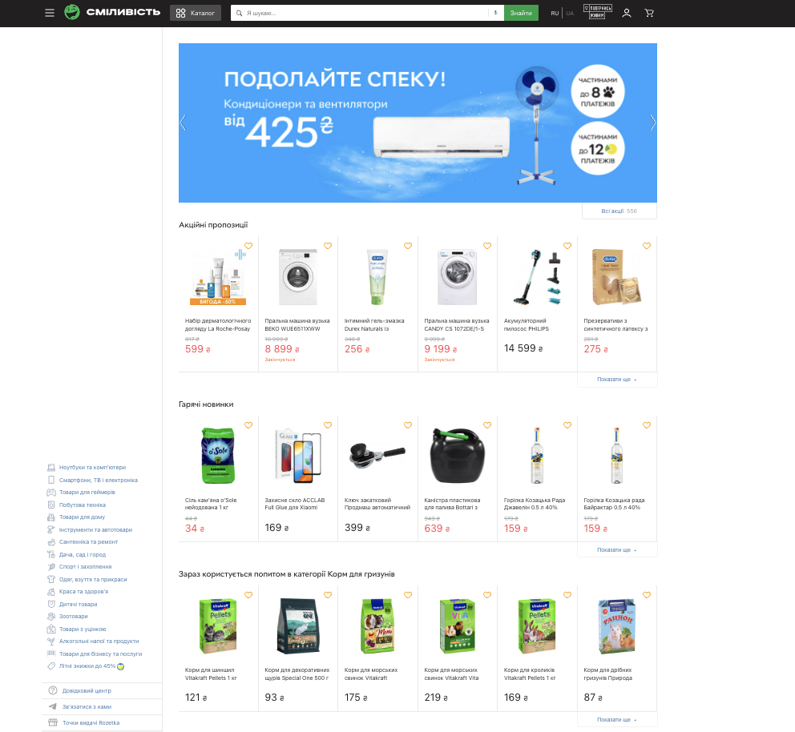

**ID** - 002

**Title** - During zooming-out of main page - the button’s text “Увійдіть в особистий кабінет” is partially hidden

**Severity** - Low

**Priority** - Low

**Environment** - MacOS, Safari browser, Version 15.5 (17613.2.7.1.8)

**Steps to reproduce**

* Go to Rosetka.com.ua
* Zoom-out the main page
* Pay attention to the button “Увійдіть в особистий кабінет” under the main menu

**Actual result** - the button text “Увійдіть в особистий кабінет” is partially hidden

**Expected result** - the button’s text doesn’t has to change during zooming-out

**Attachment:**

